Tab 1

PINN to Nonlinear PDE Models Info

Riemann problem:
- Riemann_first.pt {Not Stable}
  - Riemann_first_plt.png
  - 10k epochs
  - Tanh activation
  - No loss epochs
  - Trained in domain x = [-1, 1], t = [0, 1]
- 0Riemann_40k_PINN.pt
  - 0Loss_Riemann_40k_PINN_plt.png
  - 40k epochs
  - Tanh Activation
  - No loss Weights
  - Trained in domain x = [-1, 1], t = [0, 1]
- Riemann_40k_PINN.pt
  - Loss_Riemann_40k_PINN_plt.png
  - 40k epochs
  - Tanh Activation
  - 4 Step loss weights
  - Trained in domain x = [-1, 1], t = [0, 1]
- 2Riemann_40k_PINN.pt
  - 2Loss_Riemann_40k_PINN_plt.png
  - 40k epochs
  - Tanh Activation
  - Gradually changing loss weights
  - Trained in domain x = [-1, 1], t = [0, 1]
- Riemann_50k_ReLU_PINN.pt
  - Riemann_50k_ReLU_PINN.png
  - Not Stable graph but stable Results in range
  - 50k epochs
  - ReLU Activation
  - No loss Weights
  - Trained in domain x = [-5, 5], t = [0, 3]
- Riemann_50k_ELU_PINN.pt
  - Riemann_50k_ELU_PINN.png
  - Stable Loss plot but not good results
  - 50k epochs
  - ELU Activation
  - No loss Weights
  - Trained in domain x = [-5, 5], t = [0, 3]
- Riemann_50k_SELU_PINN.pt
  - Riemann_50k_SELU_PINN.png
  - Stable Loss plot but not good results
  - 50k epochs
  - SELU Activation
  - No loss Weights
  - Trained in domain x = [-5, 5], t = [0, 3]
- Riemann_50k_LeakyReLU_PINN.pt
  - Riemann_50k_LeakyReLU_PINN.png
  - UnStable Loss plot but good results
  - 50k epochs
  - Leaky ReLU Activation
  - No loss Weights
  - Trained in domain x = [-5, 5], t = [0, 3]
- Riemann_50k_ParametricReLU_PINN.pt
  - Riemann_50k_ParametricReLU_PINN.png
  - UnStable Loss plot and not good results
  - 50k epochs
  - Parametric ReLU Activation
  - No loss Weights
  - Trained in domain x = [-5, 5], t = [0, 3]

Heat Equation
- 1HeatEqn_30k_tanh_NN.pt
  - 1HeatEqn_30k_tanh_NN.png
  - Layers = [4, 64, 64, 64, 64, 1]
  - 30k epochs; {Stable Loss after 25k}
  - Tanh activation
  - X , Y , Z = (-1.0, 1.0)^3, T = [0,1]
  - Matches with analytical results at t = 1.5 also
  - But doesn’t match for {X , Y , Z} > 1 and < -1
  - 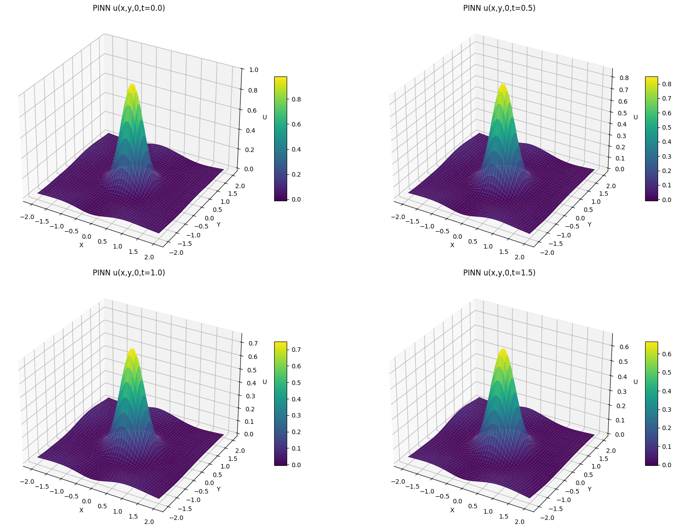
- 2HeatEqn_30k_tanh_NN.pt
  - 2HeatEqn_30k_tanh_NN.png
  - Layers = [4, 32, 16, 8, 1]
  - 30k epochs; {Very Stable Loss}
  - Similar Results to above model
  - 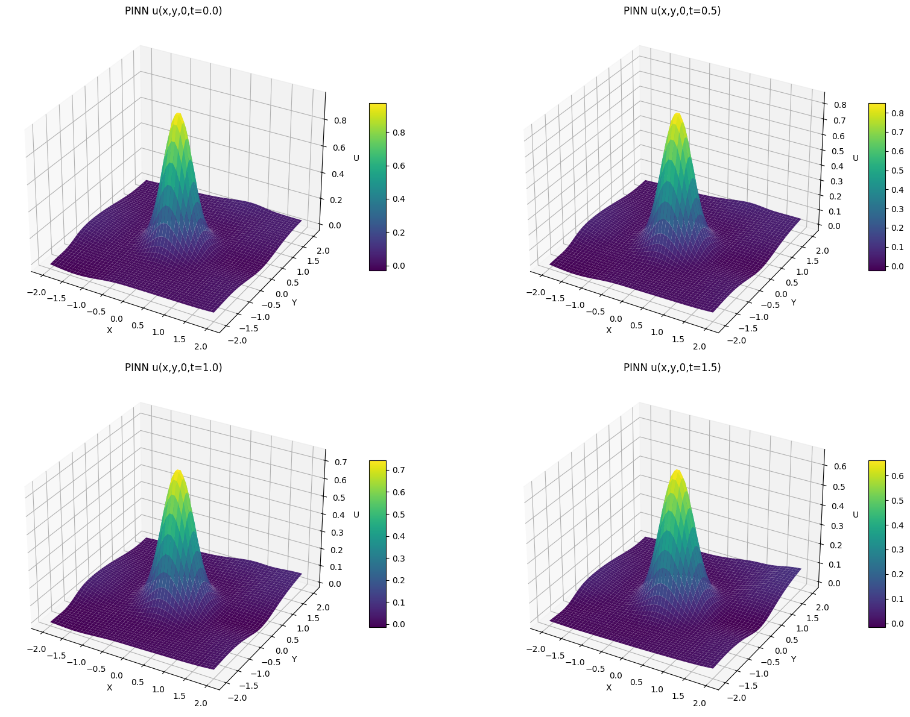
- 3HeatEqn_30k_tanh_NN.pt
  - 3HeatEqn_30k_tanh_NN.png
  - Layers = [4, 32, 8, 1]
  - 30k epochs; {Very Stable Loss}
  - Diverges more at {X , Y , Z} > 1 and < -1 (Outside the trained domain)
  - 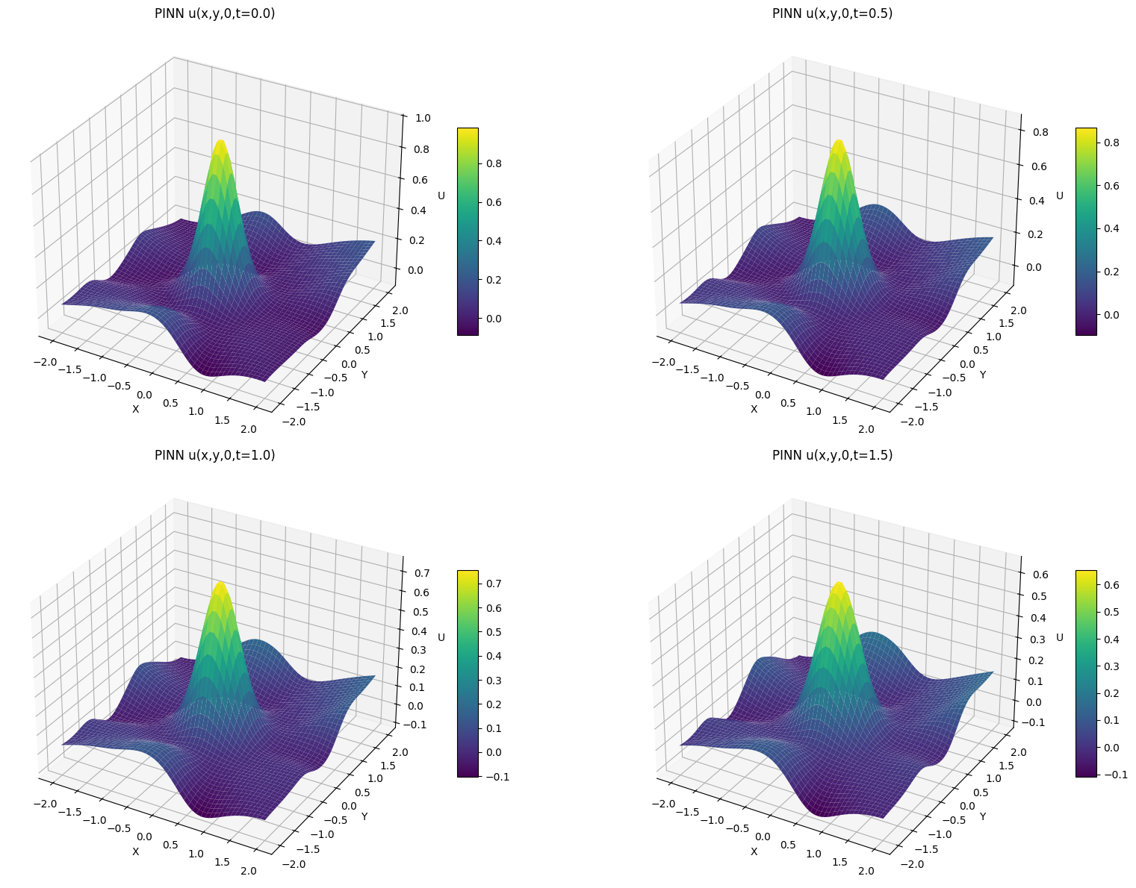

Kinematic dynamo action
- kinematic_dynamo_action_10k_tanh_NN_10lossicW_Rem100.pt
  - 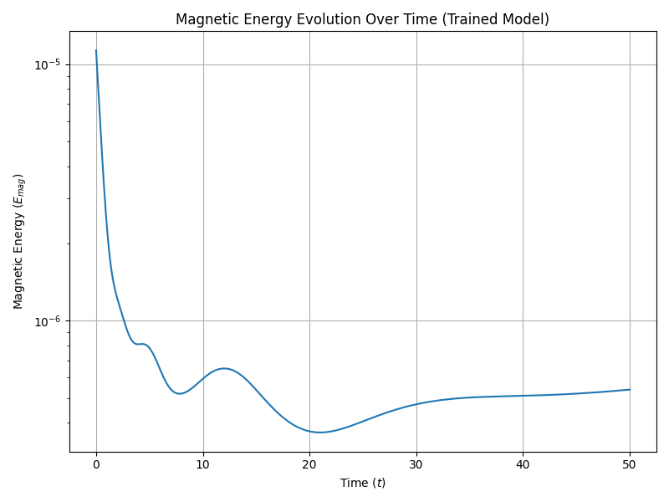
  - 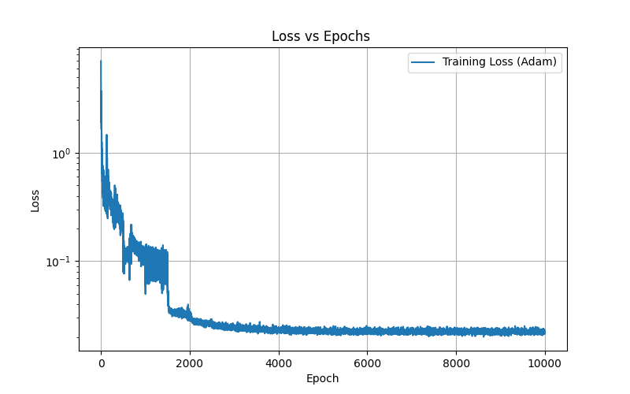
  - 10k epochs
    - Re_m = 100.0
    - A, B, C = 1.0, 1.0, 1.0
    - k_abc = 2
    - domain_min = 0.0
    - domain_max = 2*np.pi
    - T_max = 40.0
    - loss_pde = torch.mean(torch.sqrt(fBx**2 + fBy**2 + fBz**2))
kinematic_dynamo_action_20k_tanh_NN_10lossicW_.pt
  - 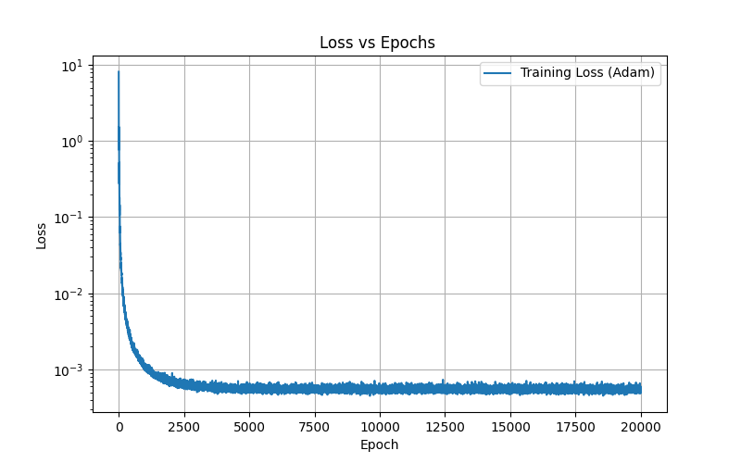
  - 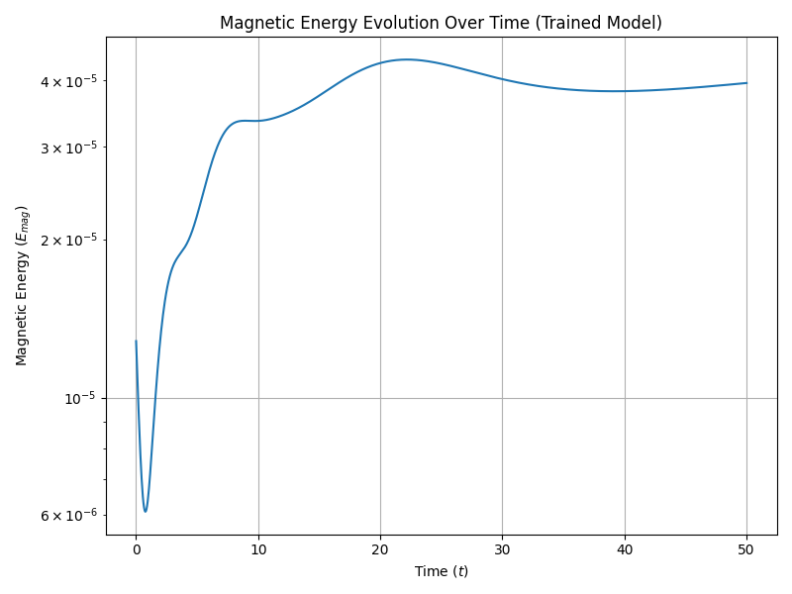
  - For Rem = 1600
  - loss_pde = torch.mean(fBx**2 + fBy**2 + fBz**2)
kinematic_dynamo_action_0k_tanh_NN_10lossicW_K=3.pt
  - 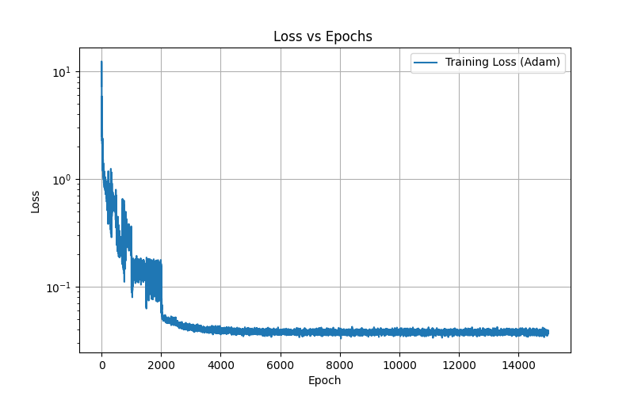
  - 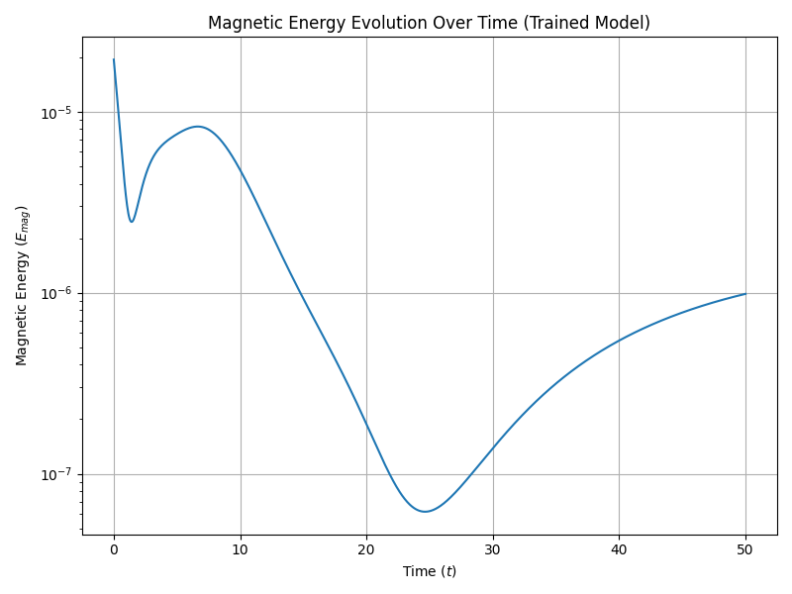
  - loss_pde = torch.mean(torch.sqrt(fBx**2 + fBy**2 + fBz**2))
  - loss = 10.0*loss_pde + 10.0*loss_div + 1.0*loss_ic # weights can be tuned
  - K = 3, Rem = 100

2D Kinematic dynamo action
B(t = 0) = B0 zcap {at t = 0}
u = uo*sin(z/2) ycap
- 2D_kinematic_dynamo_action_10k_tanh_x,y,z.pt
  - 2D_kinematic_dynamo_action_10k_tanh_x,y,z_Loss.png
  - model = PINN_Magnetic3D([4, 64, 64, 64, 3]).to(device)
  - 10k epochs
  - Tanh layer
  - 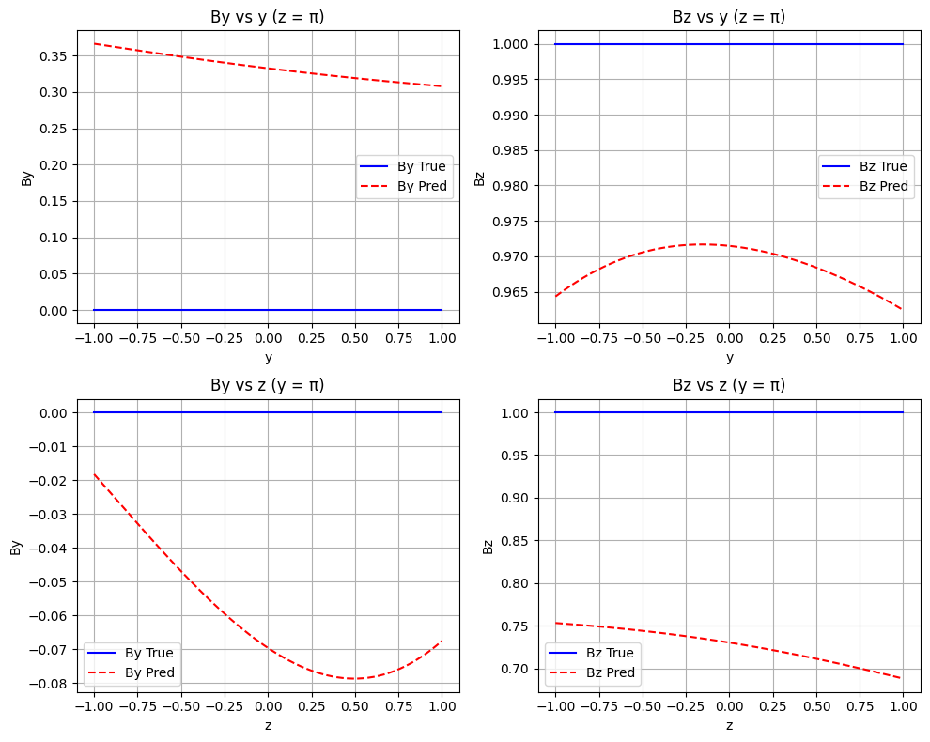
- 2D_kinematic_dynamo_action_10k.pt
  - 2D_kinematic_dynamo_action_10k_Loss.png
- 2D_kinematic_dynamo_action_10k_64*4-hiddenlayers.pt
  - 2D_kinematic_dynamo_action_10k_64*4-hiddenlayers_Loss.png
- 2D_kinematic_dynamo_action_10k_128*4-hiddenlayers.pt
  - 2D_kinematic_dynamo_action_10k_128*4-hiddenlayers_Loss.png
- 2D_kinematic_dynamo_action_10k_64*2-hiddenlayers.pt
  - 2D_kinematic_dynamo_action_10k_64*2-hiddenlayers_Loss.png
- 2D_kinematic_dynamo_action_20k_[3, 128, 64, 32, 16, 8, 4, 2]-cos-Relu.pt
  - 2D_kinematic_dynamo_action_20k_[3, 128, 64, 32, 16, 8, 4, 2]-cos-Relu_Loss.png
  - Layers = [3, 128, 64, 32, 16, 8, 4, 2]
  - Epochs = 20k
  - u = u0 * cos(pi * z / 2)
  - Activation function = ReLu

IMPROVE:
- Adaptive λ_pde, λ_ic like the paper
- Time-slab training
- Causal time weighting
- Residual connections
- Fourier feature mapping
- Higher-dimensional PDE handling

